Continuity of Operations Plan- Remote Operations for Mental Health Services
Inclusive of Behavioral Medicine, SARP, Clinical services provided by WPS

- Purpose
To provide guidance to mobilize department resources to support the continuation of services in the event that normal mental health services of SHS operations are impacted by emergency events.

Priorities for continuity of care
- Maintain essential outpatient services to address the mental health needs of BU students.
- Establish and maintain access to Point and Click.
- Maintain communication between leadership, all scheduled staff, triage staff and on-site staff (PC and AT).
- Designate staff (number contingent on presenting needs) to provide on-site support, if working remotely, for acute psychiatric situations, for individuals who present for triage in-person and for intake appointments, as needed.
- Effective communication with BUPD and Residence Life around emergency situations, initiating wellness checks and potential transports to the hospital.
- Phones will be answered by Patient Services Coordinators. Staff may be messaged through PnC if they need to return a call.
- BASICS I and II will be completed via tele therapy and will follow standard procedures for emergency triage
- SARP will follow procedures relevant to their office’s SOP.

Expectations from staff:
- Remote Access
All staff are required to maintain remote access to PnC. Please see the remote access document attached for further instructions.
2. Availability
- If scheduled to be working, providers are to be available as we are when working in the office.
- During designated lunch times, we do not need to be immediately available.
- Providers must block schedules if you are unavailable at other times. Communication will be even more crucial if staff is operating remotely.

- Best practice guidelines:
- Ensure a private, uninterrupted space for the duration of your session.
- During a telemental health session, both locations shall be considered a patient examination room regardless of a room’s intended use.
- To the extent possible, the patient and provider cameras should be placed at the same elevation as the eyes with the face clearly visible to the other person.
- Health professionals shall be responsible for maintaining the same level of professional and ethical discipline and clinical practice principles and guidelines as in person care in the delivery of care in telemental health.
- If you are disconnected during your session, either try to reconnect via Zoom or call the patient directly.

- Processes:
- Batch message to all scheduled patients
If mental health services need to transition to remote operations, a message will be sent in PnC to all patients to indicate this plan and that they can expect their clinician to contact them at the scheduled appointment time. Message will be tailored to the emergency event. (see Section V)
- If moving to Zoom, students will be contacted via PnC and provided a link at the start of their appointment that they can join a session via video.
- If moving to phones, students will be informed that they will receive a call which will come from a blocked number.
If calling, it is recommended that staff members temporarily block their cell phone number prior to contacting any students. To block your number from being displayed temporarily for a specific call:
- Enter *67.
- Enter the number you wish to call (including area code)

Appointments:
- To initiate a Zoom session, follow directions in Appendix A.
- Send the scheduled patient a link and include smart phrase .MHZOOM
- At the start of any appointment, you will need to check in your patient in PnC.
- At the top of each note, you MUST endorse “Telemedicine”, which will then open up another box where you should get exact location and phone number of the student.
- In the event that you initiated a session via Zoom but are having difficulty connecting with the patient via Zoom, call the patient via phone and follow phone procedures.

Follow Up Visits and Evaluation Clinician
- All visits will be by video (other than with designated on-site staff)
- EC appointments will be completed via video telemental health
- Appointments length should be determined by need.
- At the end of a visit, book follow up visits per standard operations.
- If students cancel/reschedules a visit, follow standard procedures.
- For off-campus referrals, follow standard procedures.

Triage
- We will maintain our current triage coverage and procedures
- In the event that the majority of staff are working remotely, we will require that at least two Behavioral Medicine staff per day will be scheduled on-site at 881 Comm. Ave. to assist on-site with acute psychiatric situations.
- Staff working remotely could be called on to assist with triage if needed.

Intakes
- Intakes will be completed while we are working remotely.
- EC will make an initial decision about whether students are appropriate for in person or video.

- Procedural items
On-Call
- On-call will operate according to normal operating procedures.
- Phones will be automatically turned over to ProtoCall at 5pm each evening.
- On-Call shifts will remain 5pm-8:30am Mondays-Thursdays and 5pm on Fridays through 8:30am on Mondays.

Calling out sick
- Follow standard operating procedures to call out sick.
- Staff are responsible for sending a message in PnC to cancel all follow up visits.

- Messaging:
Batch messaging prior to appointments:
You have an appointment on DATE with PROVIDER at LOCATION.
Due to the cessation of in person classes at the University, Student Health Services is taking precautions to keep our community healthy. Although SHS remains open for Primary Care, we want to protect students from being exposed to students who may be physically ill.
Instead, your appointment with your provider will be done via a secure video platform called Zoom.
If you agree to this format of treatment, at the time of your appointment, your provider will message you via Patient Connect with a unique link for you to join the session.
If you do not feel comfortable with this format, and would rather cancel your appointment, please do so online. Your provider will message you to discuss next steps.
Remember that emergency services are always available. To contact Behavioral Medicine, please call 617-353-3569. To contact SARP, please contact 617-353-SARP (7277)
Thank you for your understanding.
Appendix A: Using video-based platform to conduct treatment

Prior to starting a session:
Ensure a quiet space
Clear your surroundings to a blank or neutral background
Check you patient in and out as usual

To get started:
Click on the ZOOM link to get started: bu-hipaa.zoom.us
This screen will pop-up
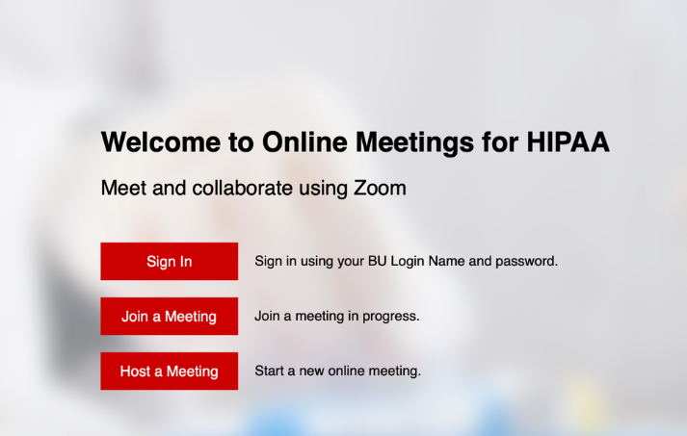
Click on “Sign In”, log in with your Kerberos password. The following screen will pop-up:
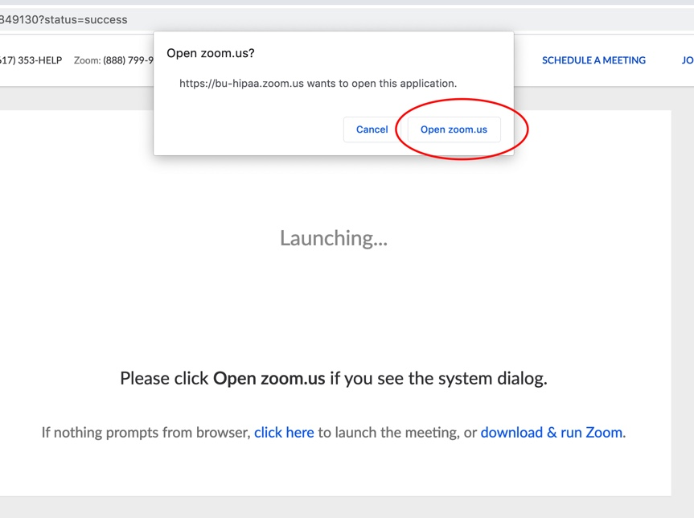

Then this window will appear:
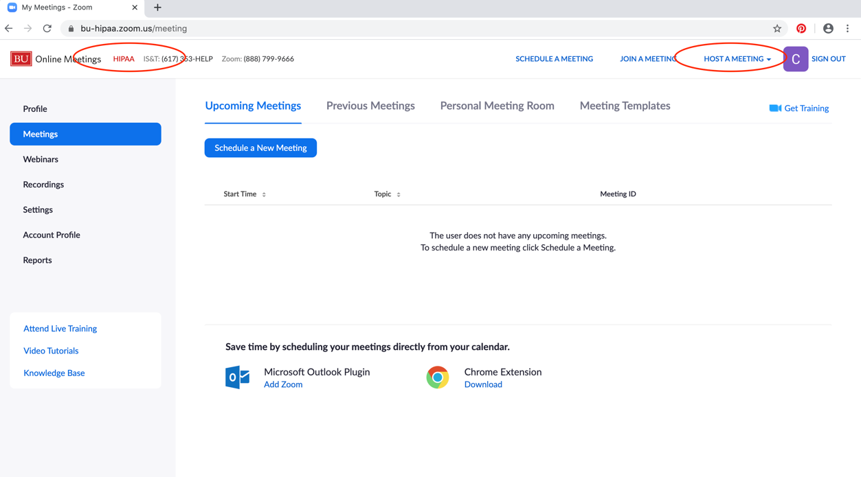
Be sure you have the HIPAA version open. Once confirmed, click on “HOST A MEETING” in the top right corner and choose “With Video On”.
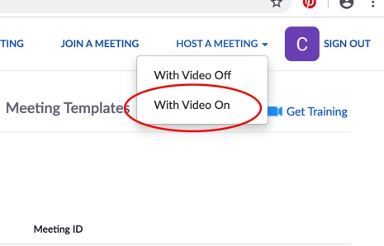
In the next screen, the following will appear. Choose “Join with Computer Audio”
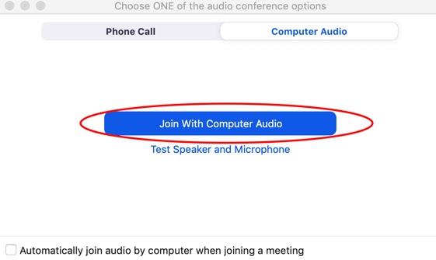
You should then appear on your screen.
To invite someone to a session, click on the top left corner of your screen on the icon below:
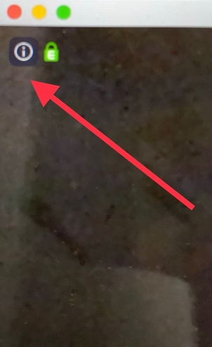
The following window will open:
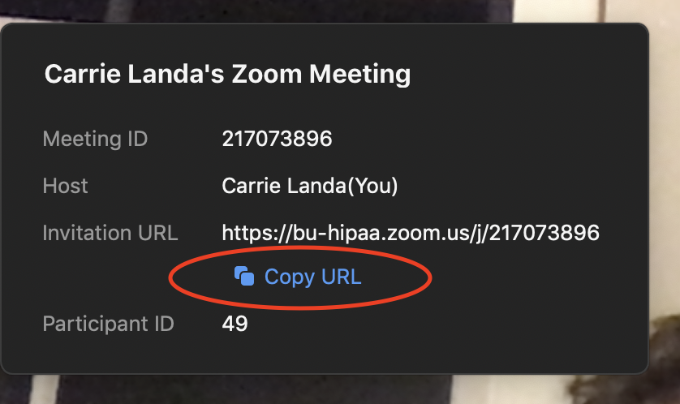
Click on “Copy URL” and paste that into your PNC message to your student at the time of your scheduled visit.
When the student joins your session, you will hear a doorbell and the following will appear:

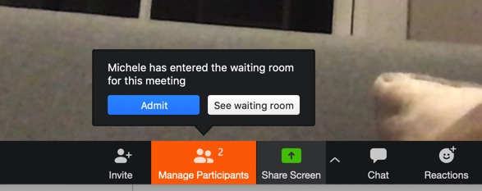

Admit the student to the session by clicking “Admit”.
They can also be left in the waiting room where you can also admit them from.
To end the session, click on the bottom right hand of the screen.
