ACCTA Conference Schedule
September 20 – September 25, 2019

Alexandria, VA
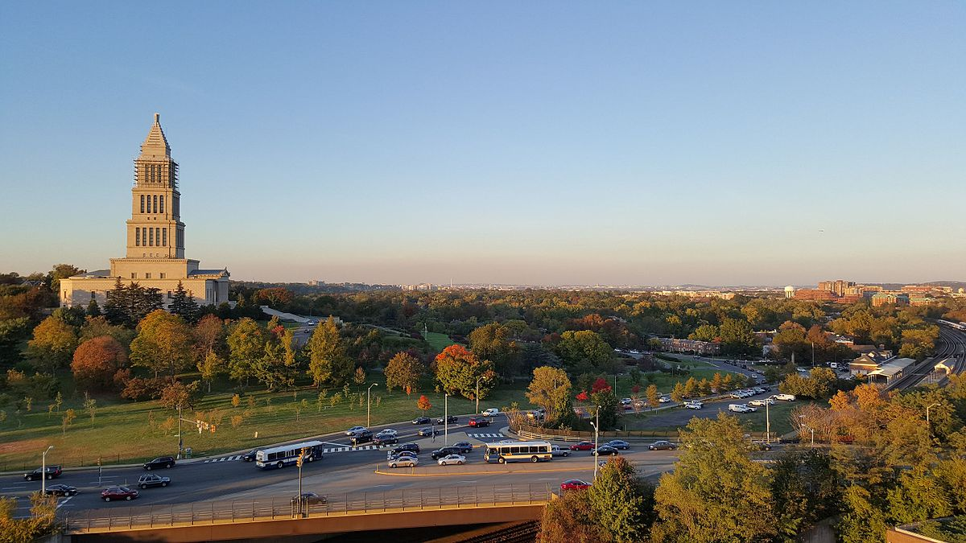

42nd Annual Conference:
From Surviving to Thriving: Engaging Your Power Within Through Connection, Leadership, and Identity

Friday, September 20, 2019
ACCTA Board Meeting Schedule
4:00 - 7:00 pm | Board Meeting | Madison
7:30 - 10:00 pm | Board Dinner | Off-Site
Saturday, September 21, 2019
ACCTA Board Meeting Schedule
8:00 - 9:00 am | Board & SCD-SC Breakfast | Potomac B
9:00 - 11:45 am | Board Meeting | Madison
9:00 - 11:45 am | SCD-SC Meeting | Salon A
12:00 - 1:00 pm | Board & SCD-SC Lunch | Madison
1:00-2:00pm | SCD-SC & Board Joint Meeting | Madison
2:00 - 4:00 pm | Board Meeting | Madison
5:45pm-6:00pm | Board Member Introductions at First Time Attendee Orientation | Washington/Jefferson

Saturday, September 21, 2019
Pre-Conference Schedule
11:00 am - 4:30 pm
11:00 am | Pre-Conference Only- Registration Open | Potomac Foyer
11:00 -12:15 pm | Lunch on Your Own (Lunch Voucher at Registration Table)
12:15 - 12:30 pm | Pre-Conference Opening  Carmen Cruz, Psy.D.  Charisse Williams, Ph.D. | Potomac Ballroom
12:30 - 12:45 pm | Your Identity as a New Training Coordinator/Director  AY Bryant, Ph.D.
12:45 - 1:00pm | Small Group Meet/Greet/Discussion  AY Bryant, Ph.D.  Charisse Williams, Ph.D.
1:00 - 2:30 pm | Session 1 (1.5 CEs)  Training Coordinator/Director Timeline and Tips  Matt Zimmerman, Psy.D.  Maureen Lafferty, Ed.D.
2:30 - 2:45 pm | Break
2:45 - 4:15 pm | Session 2 (1.5 CEs)  Managing the Internship Selection Process  Jay Manalo, Ph.D.  Charisse Williams, Ph.D.
4:15 - 4:30 pm | Break
4:30 - 6:00 pm | First Time Attendee Orientation  Mollie Herman, Ph.D.  Cecilia Sun, Ph.D. | Washington/Jefferson

Saturday, September 21, 2019
ACCTA Conference Schedule

3:00 - 6:00 pm | Registration Open | Grand Ballroom Foyer
4:30 - 6:30 pm | First Time Attendee Orientation  Mollie Herman, Ph.D.  Cecilia Sun, Ph.D. | Washington/Jefferson
5:30 - 6:45 pm | Welcome Reception (Cash Bar) | Grand Ballroom Foyer
7:00-9:00pm | Opening Session and Dinner  Welcome and State of ACCTA  Carmen Cruz, Psy.D. | Grand Ballroom
9:00 pm- Until | Social Time | Grand Ballroom Foyer

Sunday, September 22, 2019
ACCTA Conference Schedule

8:00 – 6:00 pm | Sponsor Exhibits | Grand Ballroom Foyer
7:00 - 8:30 am | Breakfast | Grand Ballroom
8:30 - 10:00 am | Keynote Address (1.5 CEs)  Trailblazing as Leadership: Sustaining Training Excellence in Challenging Times  Presenter: Theodore Burnes, Ph.D. | Grand Ballroom
10:15 - 11:45 am | Passages (1.5 CEs)  Presenters: Laura Wright, Ph.D. and Diane Hayashino, Ph.D. | Grand Ballroom
12:00 - 1:15 pm | Lunch  Annual Survey and Sponsors | Grand Ballroom
1:30 - 3:15 pm | Jay Zimmerman Diversity Scholars Programs (1.5 CEs)  Improving Diversity Training and Dialogue through more “Consciousness- raising” Experiences  Presenter: Odessa Despot, Psy.D.  Counseling African College Students: Recommendations for Developing a Culturally-effective Treatment Approach  Presenter: Lilian Odera, Ph.D. | Grand Ballroom
3:15-4:00 | Coffee & Ice Cream Break – Liaison Reports  Liaison Reports begin at 3:30 | Grand Ballroom Foyer

4:15- 5:45 pm | Concurrent Session 1 (1.5 CEs)
 | Postvention After Mass Violence: Preparing our Trainees (and Ourselves) to Provide Trauma-Centered Care  Presenter: Fiona Vajk, Ph.D. | Jefferson
 | On Whose Authority? The Opportunities and Challenges of Being an Early Career Professional (ECP) Training Director with a Minority Identity  Presenters: Michael Rogers, Ph.D., Belinda Hinojos, Ph.D., Christine Jehu, Ph.D., Lilia G. Miramontes, Ph.D., and Sonia Dhaliwal, Psy.D. | Washington
 | Building Resiliency: The Impact of Change on UCC Training Programs  Presenter: Mark Sampson, Ph.D. | Potomac Ballroom
6:00-7:00 pm | Affinity Groups/Ad Hoc Groups | Jefferson, Washington, Potomac, Grand Ballroom
7:15 pm | Dinner on your own or with ACCTA groups
9:00 pm | Social Time/ACCTA Game Night | Grand Ballroom

Monday, September 23, 2019
ACCTA Conference Schedule

7:00 - 8:15 am | Breakfast | Grand Ballroom
8:15 – 9:45 am | Concurrent Session 2 (1.5 CEs)
 | Subtitles to Relationships: Strengthening Connection, Emotional Intelligence, and Leadership Abilities through Nonverbal Communication Skills.  Presenter: Michael Adams, Ph.D. | Jefferson
 | Surviving (and Maybe Even Thriving from) Difficult Feedback Experiences  Presenter: Brandy L. Smith, Ph.D. | Washington
 | Systematic Approach to Implementing APA Supervision Guidelines within a Competency Based Supervision Model  Presenter: Michael Rogers, Ph.D. | Potomac Ballroom
10:00 - 11:30 am | Concurrent Session 3 (1.5 CEs)
 | Redefining Leadership: How “Traditional” Leadership Models Fail to Support a Social Justice Mission and Therapist- and Training Director-Aligned Values in UCCs  Presenters: Laura DiPasquale, Ph.D., Raquel Bateman, Ph.D. and Durriya Meer, Psy.D. | Potomac Ballroom
 | The Hunger Games: Developing an Internship from Scratch Under the New Match Imbalance  Presenters: Christine Love Sterk, Ph.D., Elizabeth Stout, Ph.D., and Amy Miller, Psy.D. | Washington
 | Keeping Training Programs in Step with Counseling Center Trends  Presenters: Kenli Urruty, Ph.D. and Jason Hindman, Ph.D. | Jefferson
11:30-12:30 | Lunch  Boxed lunches available for everyone prior to excursions | Grand Ballroom
12:30 pm - | National Museum of African American History and Culture Excursion  Leave for Excursion ½ hour prior to entrance time (Group Entrance times at 1:00, 2:00 and 3:00, respectively)  Additional Excursions | Off-site
 | Dinner on your own

Tuesday, September 24, 2019
ACCTA Conference Schedule

7:00 - 8:30 am | Breakfast | Grand Ballroom
7:30 - 8:30 am | Leadership Breakfast  Board and SCD-SC | Grand Ballroom
8:00 - 8:50 am | Standing Committee Meetings | Grand Ballroom
9:00-10:15am | SCD Unopposed Discussion about Excursion to the National Museum of African American History and Culture (1.5 CEs) | Grand Ballroom
10:30-12:00pm | ACCTA Diversity Business Meeting and Conversation Hour | Grand Ballroom
12:15 - 1:15 pm | Lunch  Officers Reports and Call for Nominations | Grand Ballroom
1:15 - 2:00 pm | Group Picture (*Location TBD) | Courtyard
2:15 -3:45 pm | Concurrent Session 4 (1.5 CEs)
 | Finding Meaning through Identity, Leadership, Social Justice, and Training: Creating an Innovative International Training Experience for Interns  Presenter: Natasha Maynard-Pemba, Ph.D. | Jefferson
 | Connecting is Key! Developing Your Identity as a Training Director through Affiliation and Support  Presenters: Bethany Riddle, Ph.D., Sung Kim-Kubiak, Ph.D., and Sarah E. M. Nolan, Ph.D. | Potomac Ballroom
 | Surviving to Thriving: Identity, Connection, and Self-care through the Arts  Presenters: Randal, Boldt, Psy.D. and Sterling Watson, Psy.D. | Washington
4:00 - 5:30 pm | Culture Sharing | Grand Ballroom
6:00 - 7:00 pm | Reception (Cash Bar) | Grand Ballroom Foyer
7:00 - 9:30 pm | Dinner and Closing Session  Helen Roehlke Award  Awards and Recognitions | Grand Ballroom
9:30 pm - 12pm | First-ever ACCTA Dance, Social Time & Good-byes | Grand Ballroom

Wednesday, September 25, 2019
ACCTA Conference Schedule

7:00 – 8:00 am | Breakfast on your own
8:30am-5:00pm | Become an APA Internship Program Site Visitor  Register separately through APA  Contact the APA office of Program Consultation  and Accreditation at apasitevisit@apa.org  Lunch Provided
11:00-5:00pm | Preparing an APA Accreditation Internship Self-Study  Register separately through APA  Contact the APA office of Program Consultation  and Accreditation at apasitevisit@apa.org  Lunch Provided

